# **Workplace Niceness**

### In Pursuit of Cynicism

Zoe's avatar

[Zoe](https://substack.com/@zoeffc)

Apr 11, 2025

2

[2](https://femmefuturescooperative.substack.com/p/workplace-niceness/comments)

2

Share

Hi there,

A couple of weeks ago, sat down with my Therapist and declared that “I am done with nice people.” She looked at me like I was crazy. Surely that’s not what I meant.

In fact, it is what I meant.

I feel like we use “niceness” as a protection from vulnerability and authenticity. I have known so many people in my life who use niceness as a wall to keep people out. That is what I am over — I am not done with kindness or compassion or empathy. The difference is that each of those comes from a well within a person, rather than a surface level reaction that is societally approved of… aka, “niceness”.

Unfortunately, [cynicism is bad for your health](https://www.nytimes.com/2024/09/20/well/cynicism-trap-health.html), and I am slowly growing out of my pessimistic nature. That being said, I don’t always see the best in people, and at work, I don’t always see the positive reframe on a challenge or have empathy for what seems to be a stupid decision. In the words of a classic pessimist: I am a realist. Here’s the thing: whether the glass is half full or half empty, my perception of it is authentic to me, and being authentic is one of my grounding values.

The dilemma: professional etiquette dictates niceness, but networking requires vulnerability and authenticity, and sometimes, cynicism.



artist unknown

Before I go any further — let’s do the housekeeping.

First, if you are not already a subscriber and you resonate with any of the following descriptors, consider joining the cooperative: (1)Early-career professional; (2) Feminist; (3) Do-gooder; (4) Former Gifted Kid; (5) Overachiever; or (6) Capitalism-hater.

Subscribed

Second, if you like what I am saying and it makes you think of someone in your family/office/friend group, send it their way.

[Share Femme Futures Cooperative](https://femmefuturescooperative.substack.com/?utm_source=substack&utm_medium=email&utm_content=share&action=share)

Third, I say some personal and vulnerable shit every week. Say some vulnerable shit back. It’s called a community.

[Leave a comment](https://femmefuturescooperative.substack.com/p/workplace-niceness/comments)

Okay — back to it.

Earlier this week, I was at an All-Staff meeting. An element of this meeting was a cross-department get-to-know-you activity. We were directed to form groups of four to five people who you did not work closely with. As these instructions were being announced, one of my friends/colleagues leaned over to me and teased that this sounds like something I would *love*. He’s right — I hate this stuff. Forced bonding has never worked for me. Even now, I am having flashbacks to middle school group projects. No, thank you.

Even though this is not my thing, I didn’t have a choice in whether or not to participate. As soon as we were released to find our groups I navigated to the side of the room and proceeded to look lost until someone took pity on me and recruited me into his group.

This guy who saved me is a long-timer at my organization and is well regarded and generally a helpful person to know. (Reader, he would be a great person to form a professional connection with.) Over the course of the activity, we were given different conversation prompts. It felt a little silly to my cynical brain that hates forced bonding. To make matters worse, it was a part of a larger effort that has generally been poorly received across the organization.

Without thinking about it, and I swear that my intension was not to be sarcastic, I asked my group “what do you think the desired outcome is of this exercise?” The guy who saved me burst into laughter, (Heck yea! Connection!), and responded with an equally cynical comment.

Remember at the start of this note where I said that connection sometimes requires cynicism?

I stumbled upon an [interview](https://crooked.com/podcast/offline-pc-small-group-houthis-signal/) with Charles Duhigg, the author of Supercommunicators. One of the ideas that stuck with me was about how human brains literally go into alignment with each other — that is what it means to connect. When you click with someone, that is your brain patterns mirroring each other. When you feel disconnected, likely those brainwaves aren’t lining up. [Here](https://behavioralscientist.org/the-everyday-supercommunicators-who-get-groups-in-sync/) is a summary of an idea that I found super fascinating, in the author’s own words.

If I could go back in time and have everyone behave nicely, I would not have walked away feeling a little more connection with the people in my organization. If I had made that comment and someone gave me a nice answer, we would have walked away disconnected.

This interaction that I had at the All-Staff meeting was a moment of connection — of a group of brains literally coming into phase with each other — caused by a shared moment of honest cynicism. I would hypothesize that “niceness” leads to disconnection where authenticity, even if that is of a negative type, leads to connection.

So this is my plea: go forth into the corporate landscape with authenticity. Don’t be overly cynical, but don’t be afraid of negativity. Don’t just be nice.

Best,

Zoe

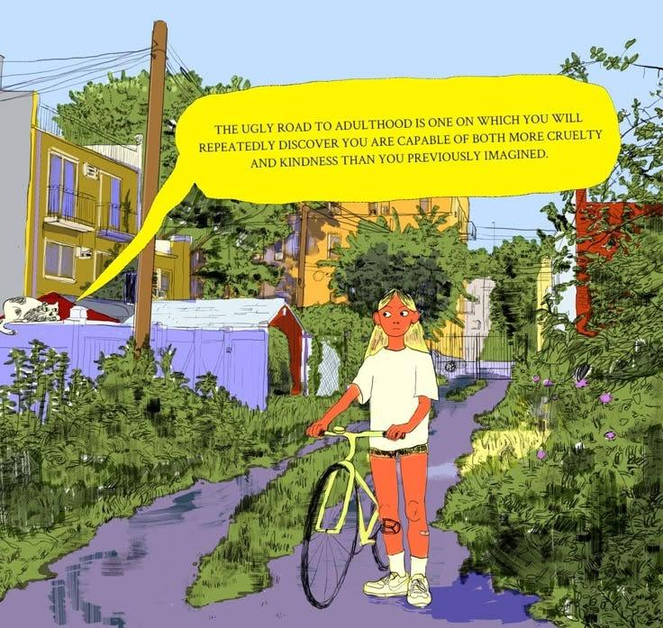

artist unknown